**The written analysis of UFO sighting with Java script**

# The objective of the assignment is to create a visualization for the UFO sightings information stored in Jason file and facilitating user to filter based on date, city ,state, country and shape.

The coding for the project is done based on Java script ES6+ where Java script functions were converted to arrow functions, deployed loops to iterate through large amount of data.

The most challenging part was to apply filter, save the filtered data and creating an if statement to hold the data for the filtered button.

# Results

The result of the project is creating a nice looking web page which can grab users attention where short article written about the UFO’s and data presented in table for each UFO sightings.

The website have the option to filter the information based on dates, city, state, country and shape of the UFO.

Since Java is the front end developer language, the web can be modified to make the web page more appealing; the main page of the site looks like this;

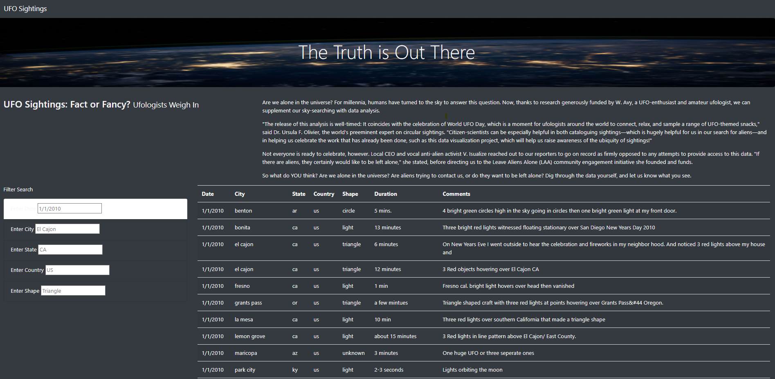

# Summary

# Drawback

The draw back of this web page is that, it is not giving drop down option to select the date/ city/state and country, user need to type the date/city or state to retrieve the information. Also, the date need to be entered specific format in order to get the filtered result.

# Recommendation

It would be nice if webpage provide drop down option to filter the data